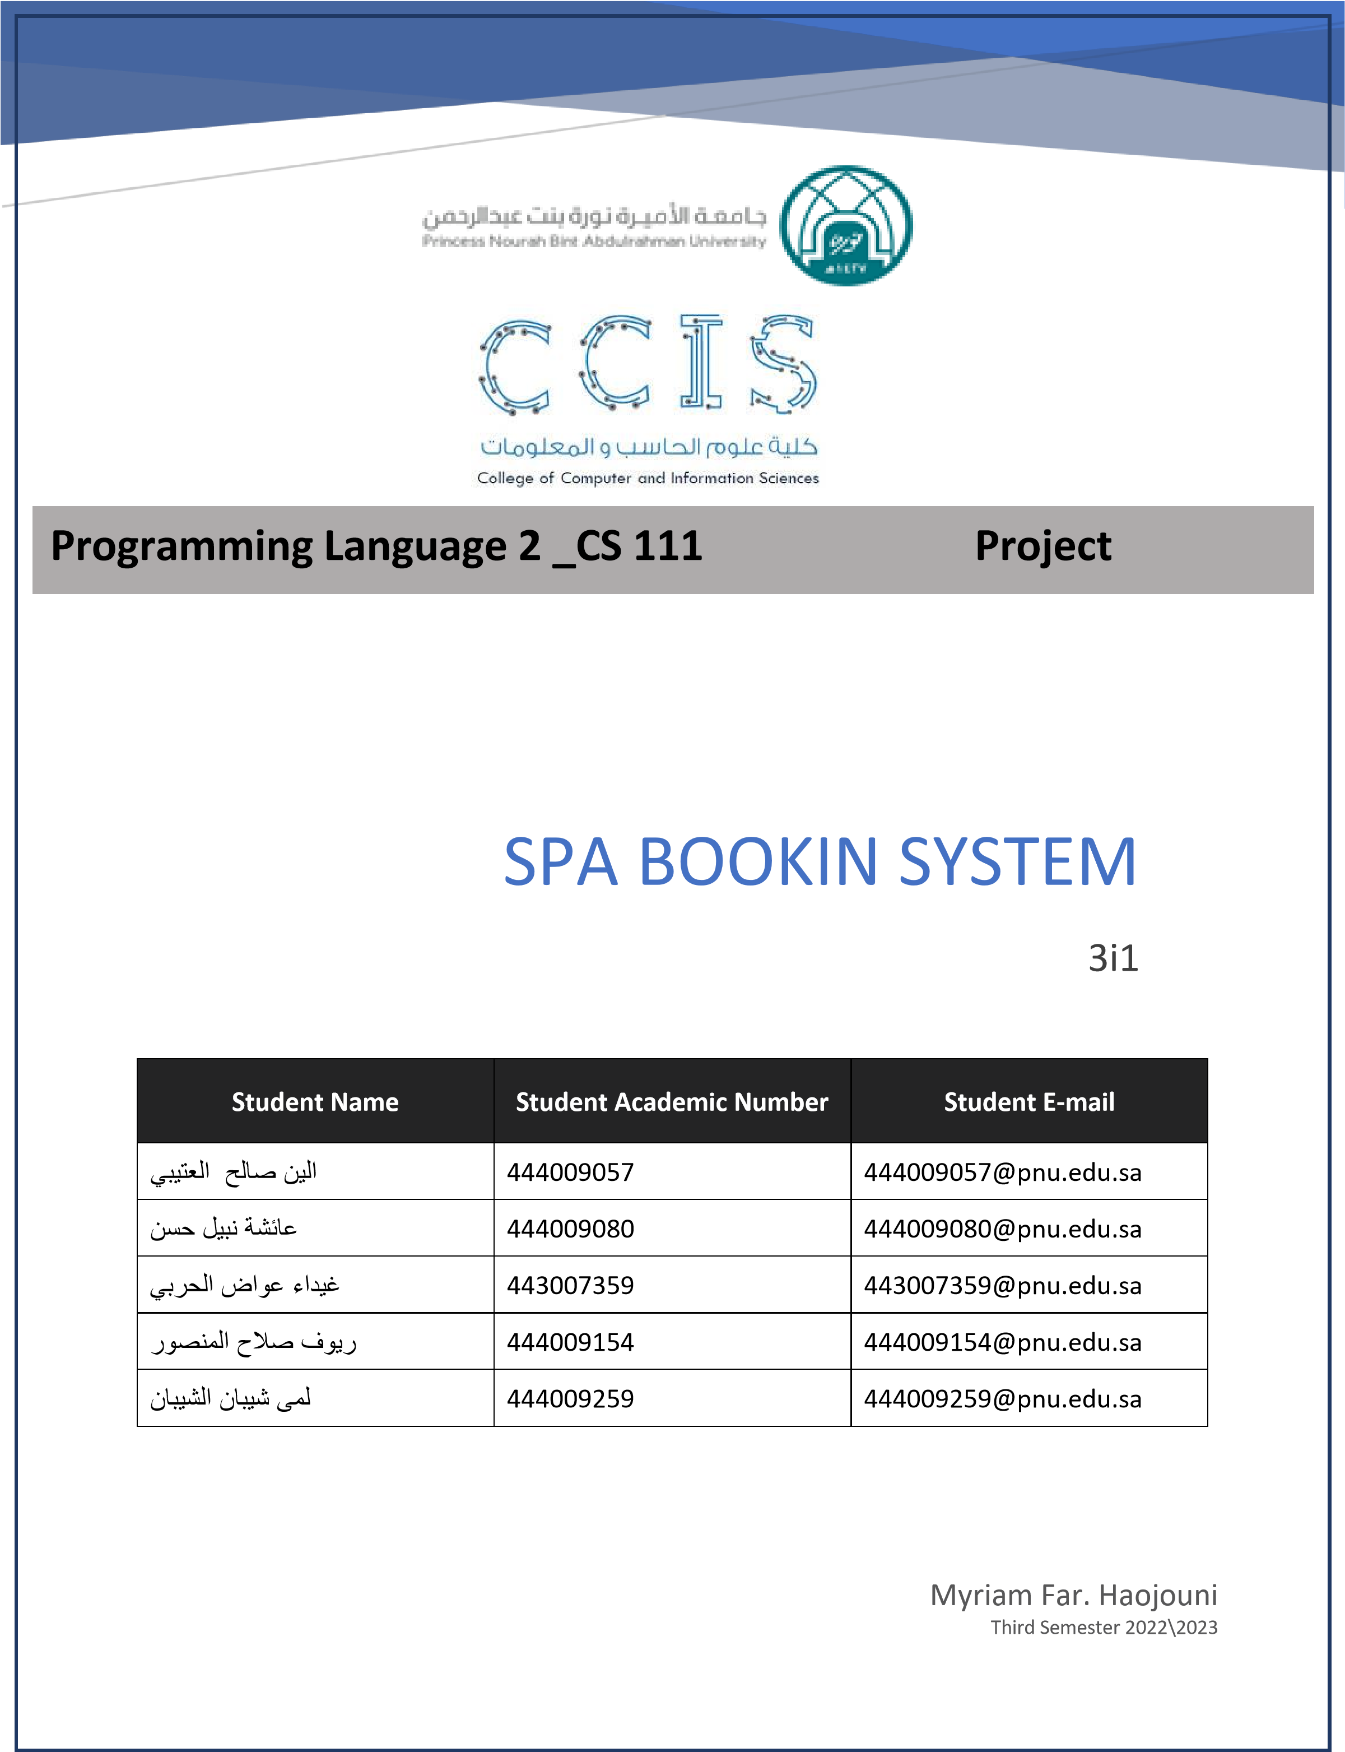

# I Project overview

Spa booking system, allows customers to book appointments for spa services. It includes the services offered by the spa: Swedish massage, deep tissue massage, deep face cleaning, nail manicure, and gel polish. It also shows the available appointment times and employees who can provide the services. Customers can view the available appointments and employees. Customers can select a service, appointment time, and employee. Customers can view their bookings and cancel appointments.

# II Project class diagram

1

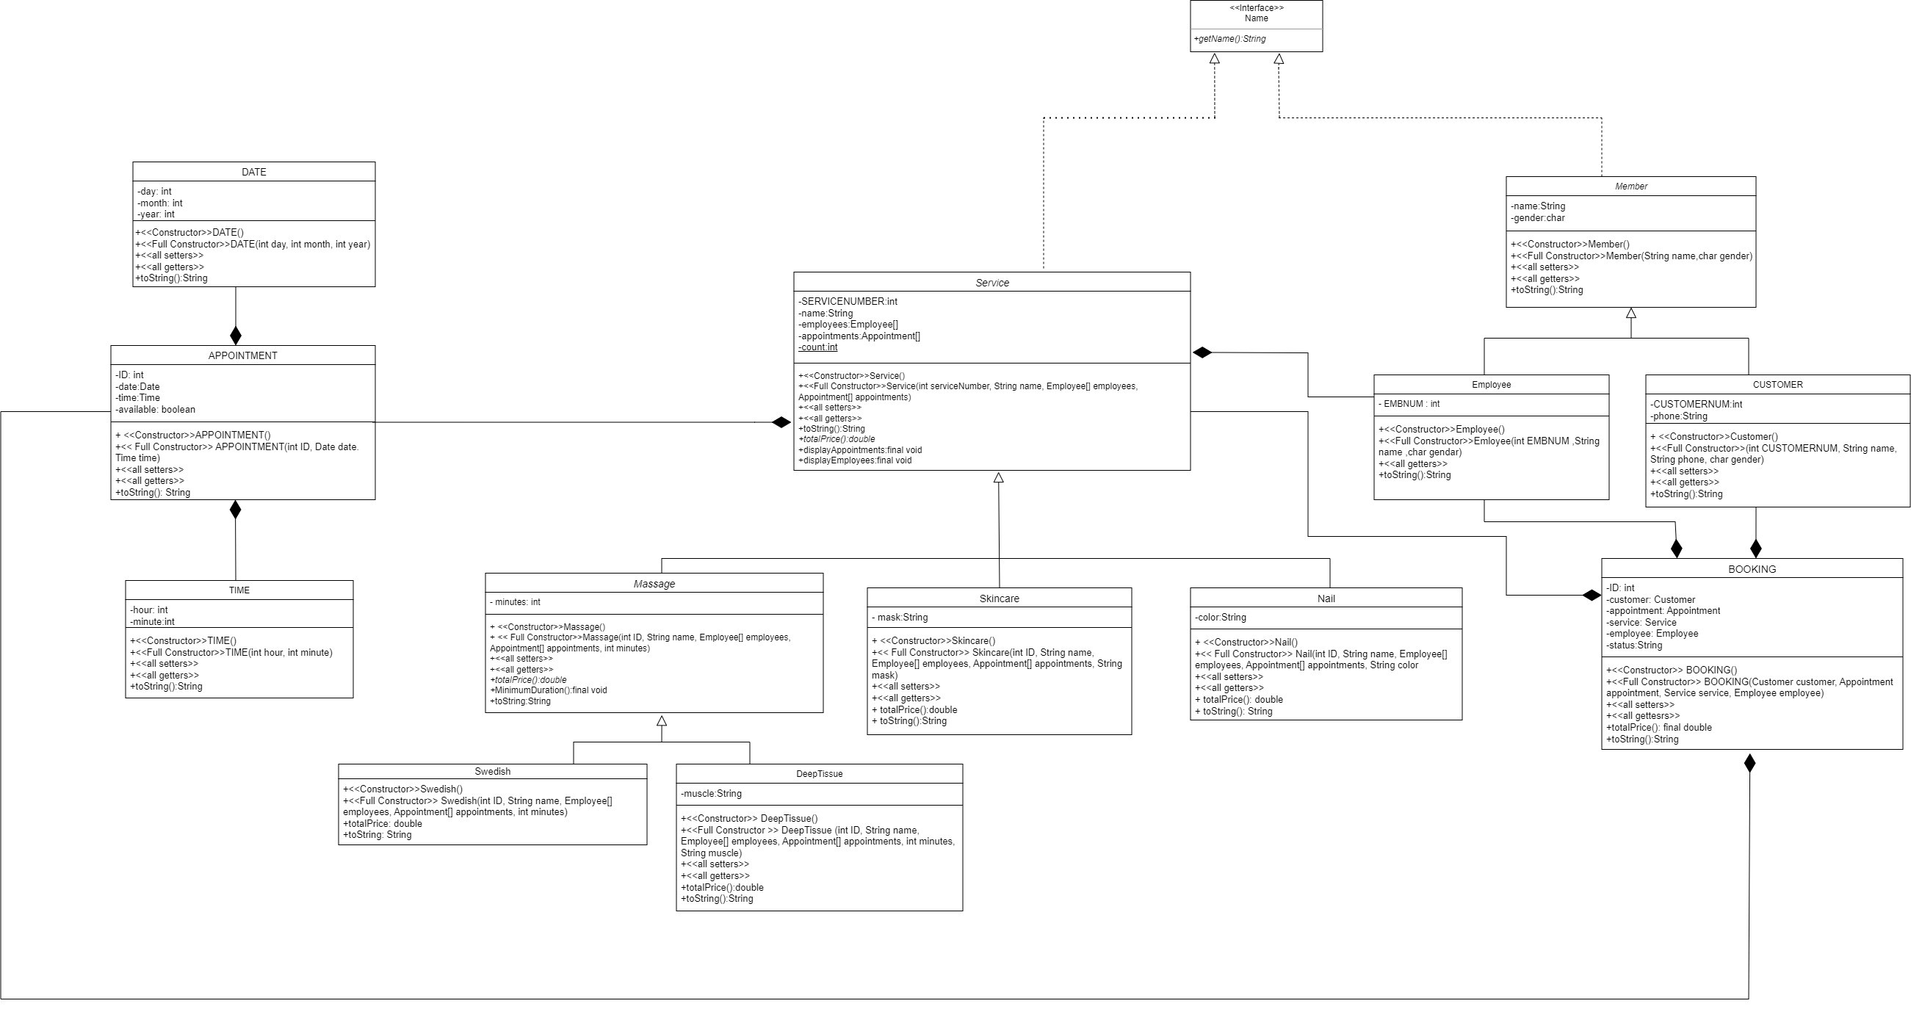

**III**

**Concepts**

**covered**

**III.1**

**Interface**

**III.2**

**Inheritance**

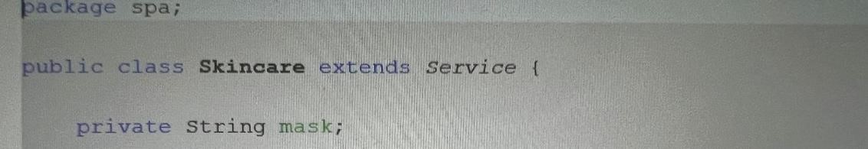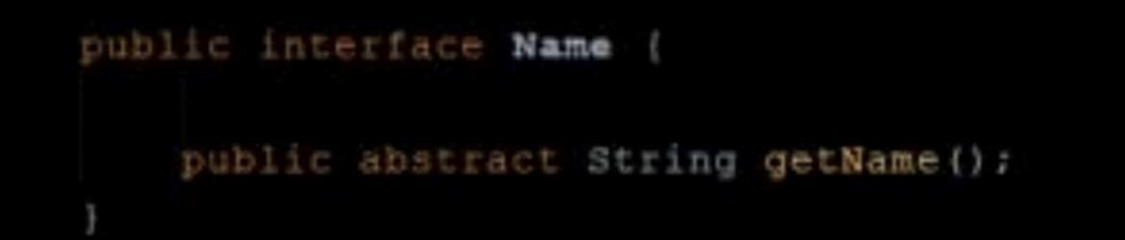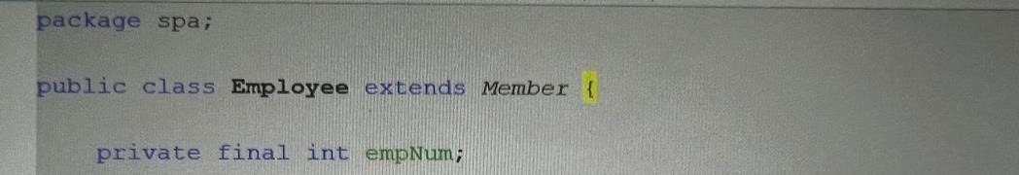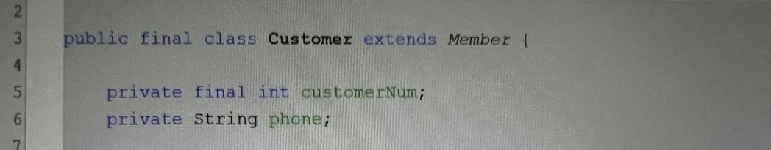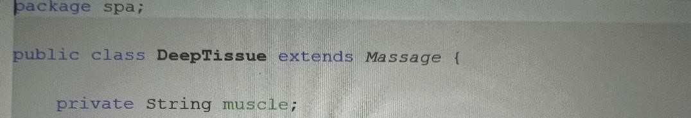

**III.3**

**Abstract classes**

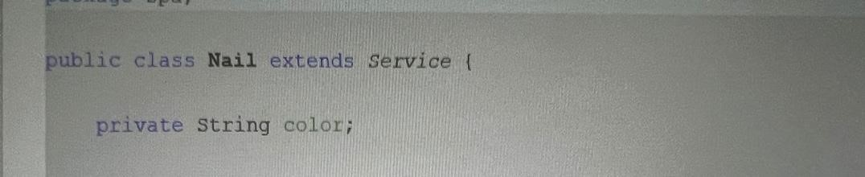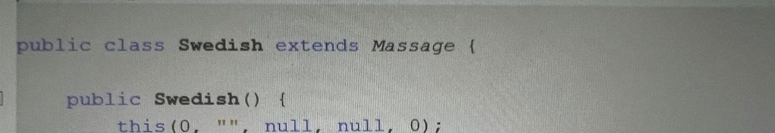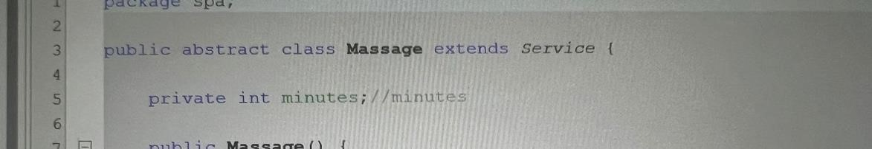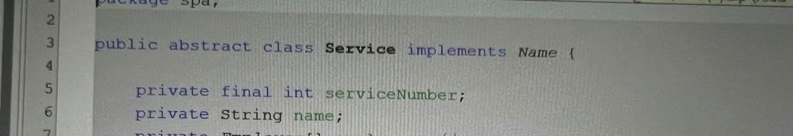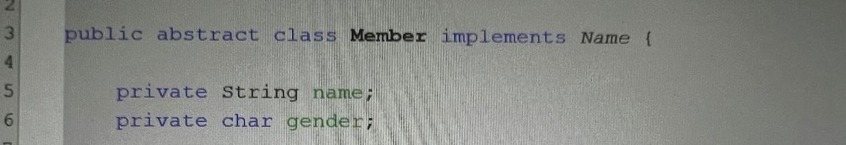

## III.4 Polymorphism

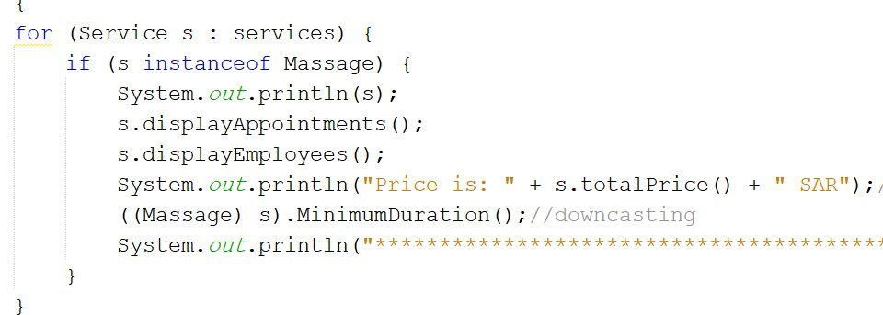

## III.5 Composition

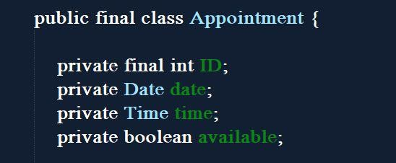

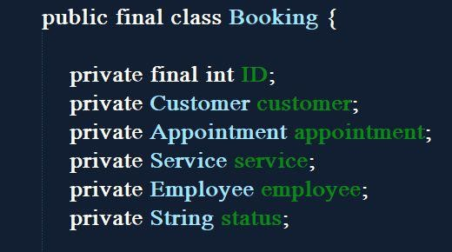

## III.6 ArrayList (in the main)

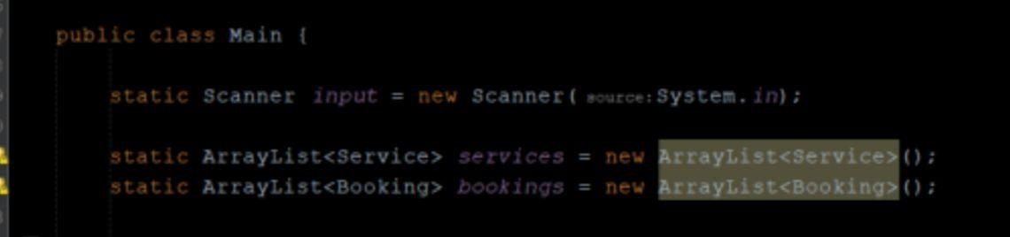

## III.7 Array (with composition)



## III.8 Graphical user Interface

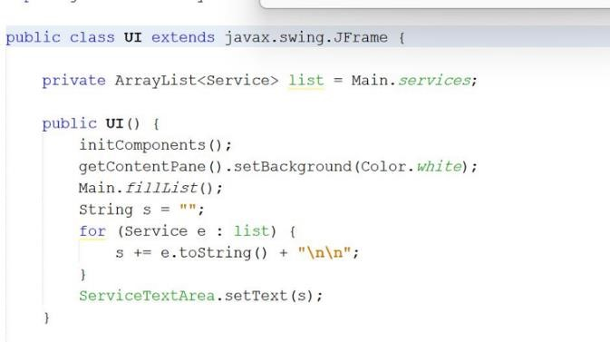

## III.9 exception handling

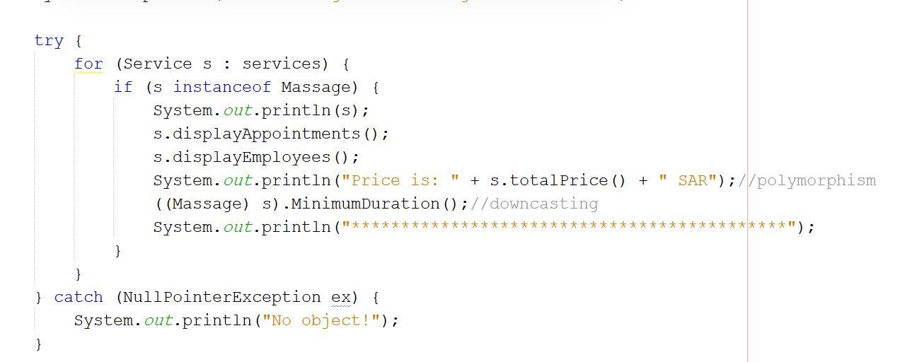

## III.10 Files

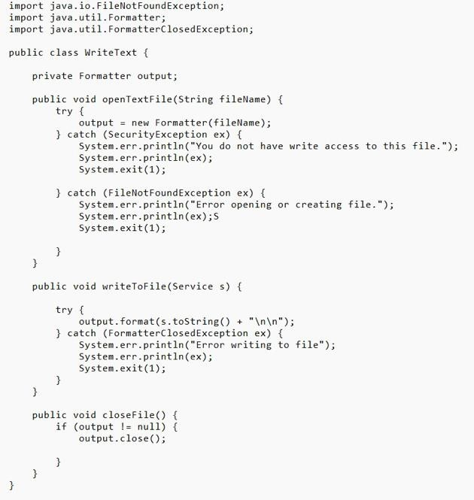

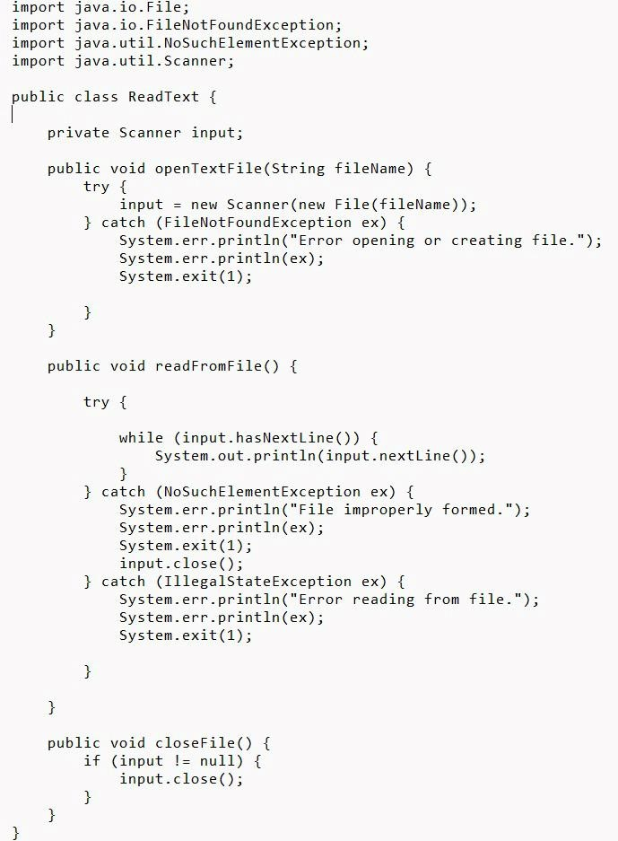

# IV Main Class

The main class contains two ArrayList : of the type booking, the type service and the main method.

In the main method, we do the following:

We call the method fillList(); to fill service ArrayList

We call the method menu();

We read an integer from the user using Scanner that represents the choice from the menu, and we handled all the exceptions that may occur

Inside the try block, we used do-while loop to continue displaying the menu until the user choose #11

, Inside the do-while we have a switch and it has 11 cases the first case:

We called the method displaySpaServices(); and we passed the service ArrayList to it It will display the services, the appointment, the employees and price.

Second Case:

We call the method and displayMassage(); it will display the massage if the service instance of massage , the appointment, the employees and price.

The third case:

The user will enter the service number, Call method seeAppointments(); to See the available appointment and display it

The fourth case:

The user will enter the service number. Call method seeServiceEmplyees(); to See the available employees and display it

The fifth case:

Call the method makeBooking(); it will display it will ask the user to enter service Id and display a message if the service Id invalid or not if yes it will display the appointment and employees and it will ask the user to enter their Id, name, phone number, gender and confirm booking Y/N.

The sixth case:

Call the method displayBooking(); the user will enter the booking Id if it’s find or not, if yes it will show the booking.

The seventh case:

Call the method cancelBooking(); the user will enter the booking Id if it’s find or not, if yes it will ask if you want to canceled the booking or not and then will display the result.

The eighth case:

It will call the main method from class UI and display the GUI.

The ninth case:

We created the object read from ReadText class and it will called the method openTextFile();

readFromFile(); and closeFile();

The tenth case:

We created the

object write from writeText class

and it will

call openTextFile method then we used

Enhanced for and call writeToFile To store services array data then call closeFile method

The eleventh case:

It will display “Thank you for booking with us!” and it will ex

it the switch.

In the catch(InputMismatchException e)block it will display invalid input.

The out

put:

